**Title: Capacitance Matrix Methods**

**Presenter: Marcus Sarkis,**

**Department of [Mathematical Sciences](https://www.wpi.edu/academics/departments/mathematical-sciences)    
[Worcester Polytechnic Institute](http://www.wpi.edu)**

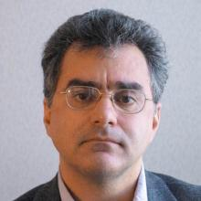

In this talk we revisit some of the developments made between the direct substructure methods introduced in the early ’60s and the first international conference on domain decomposition methods held in Paris in January 1987. Among these developments, we travel over Capacitance Matrix Methods/Ficticius Domain Decomposition Methods and some subsequent contributions that provided the initial basis for the area of iterative substructuring methods. These earlier methods started to come back again such as in fractional derivatives problems with complex  geometry. I will try to make the talk very introductory and easy to understand.

**Bio**: Marcus Sarkis received his Ph.D. in Mathematics from the Courant Institute in 1994. As a NSF Postdoctoral Fellow he joined the Departments of Computer Sciences and the Aerospace Engineering of the University of Colorado at Boulder. In 1998 he moved to Worcester Polytechnic Institute as Assistant Professor in the Mathematical Sciences Department and received a NSF CAREER Award (2000). In 2001, he also joined the Instituto de Matematica Pura e Aplicada in Rio de Janeiro, Brazil as a Researcher and in 2012 he became Professor at WPI. His main areas of research are domain decomposition and finite element methods and he has advised 6 PhD students.