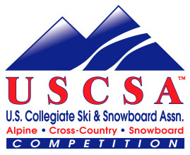
USCSA Citizen’s Cup
Prospect Mountain, Woodford, VT
Saturday, February 14, 2009

Registration Form

The U.S. Collegiate Ski & Snowboard Association (USCSA) is proud to announce our third annual Cross Country ski race open to the public.
Come join us for this exciting event and meet collegiate skiers from schools all around the Northeast! For high school racers, this will be a great venue to find out collegiate racing opportunities.

Race Length: 5k or 10k
Race Technique: Freestyle
Start Details: 1 racer every 30 seconds, Race starts at 10:00 am. All collegiate racers will start first, followed by 10k racers then 5k racers. [It is anticipated that the first Citizen’s Cup racer will start around 10:30 am.]
Race Fee: $20 per racer ($15 for high school students), $25 for day-of race registration ($20 for high school students). Make checks out to ‘ECSC Nordic Division’.
Awards: Top 3 in each category (High school, Open, 50+)
Name: _____________________________________________________________
Mailing address: _____________________________________________________
________________________________________________________________

Email address: _____________________________________________________
Phone number(s): __________________________________________________
Birthdate: ___________________ Age on race day: ________________
Race distance: 5k 10k Sex: M F Race category: High School Open 50+
Mail registration to: ECSC Nordic Division, Amy Lane, 1759 E. Mountain Rd., Westfield, MA 01085
This race is presented by the Eastern Collegiate Ski Conference Nordic Division.
Any questions about the race can be directed to: Amy Lane at (413) 572-3228 or ECSC.Nordic@gmail.com.
Register online at: skireg.com.

