CAUTION!!! When measuring peak-to-peak amplitudes on the scope, do NOT use the automated MEASURE Pk-Pk function on the scope!!!

This will give an amplitude that is too large. Why? It's a combination of your signal and the way the scope's software defines the peak-to-peak measurement function. As shown in Figure 1 below, any real signal has noise superimposed on the intended signal. Suppose the noise has peak-to-peak amplitude of V_{N(p-p)}; the signal amplitude we want to measure is V_{SIG(p-p)}. For the peak-to-peak measurement function, the scope reports the difference between the maximum sample value and the minimum sample value - which includes the effects of the noise. As a result, the scope reports a peak-to-peak amplitude of V_{N(p-p)} + V_{SIG(p-p)}, which is too large.

Fig. 1. Scope's wrong measurement of V_{PK-PK}.

To avoid having your measurement incorrectly affected by the noise amplitude, you need to manually place the voltage measurement cursors in the center of the noise "fuzz" as shown in Figure 2. This gives the correct peak-to-peak amplitude.
Fig. 2. Manually placing voltage cursors in center of "fuzz" for correct V_{PK-PK}.

(OVER)
For example: with a 100mV peak-to-peak signal input to the scope, the "MEASURE" function gives an incorrect result of 112mV:

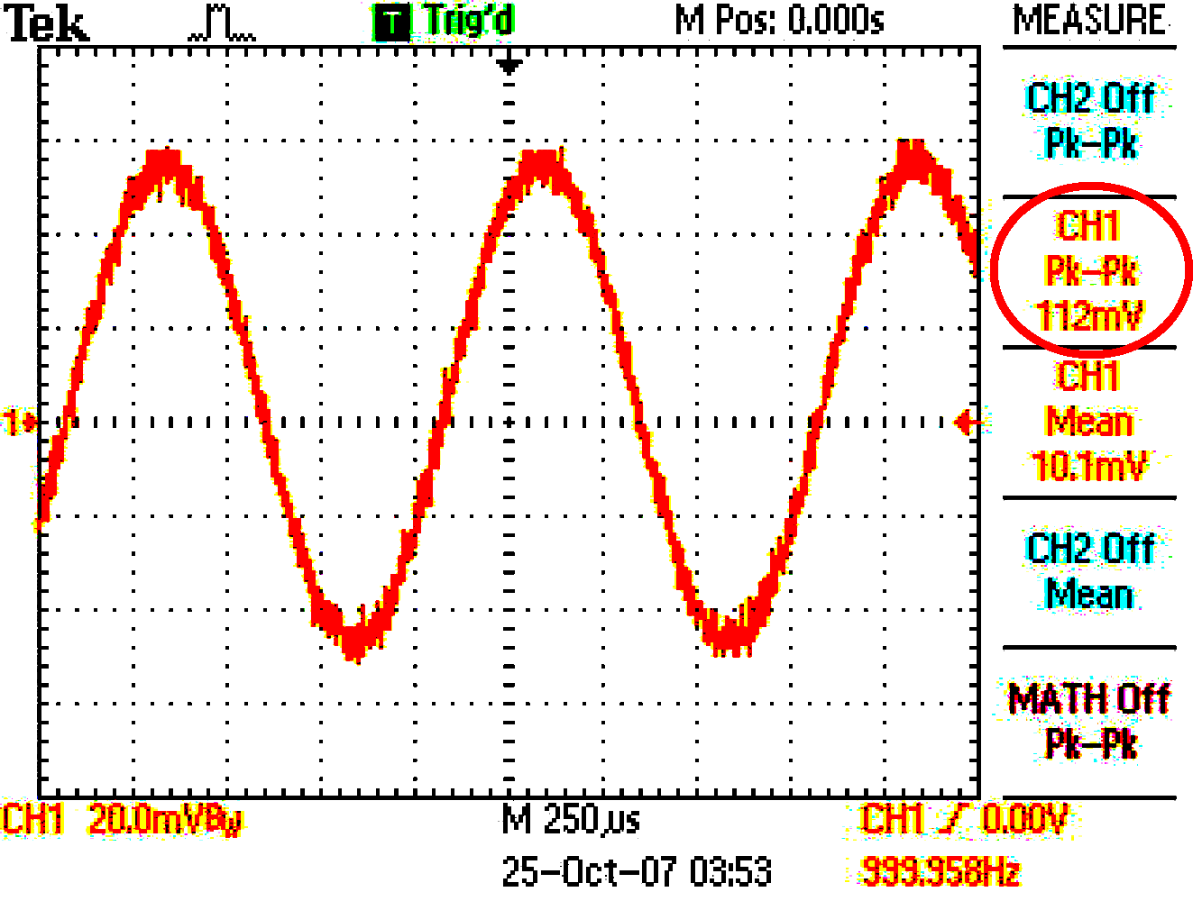

This 12% error is worse than the combined effect of 5% resistor tolerances! Using cursors centered in the "fuzz" gives the correct reading of 100mV peak-to-peak:
