Steps to solve a Linear Programming Example in Excel (Please find embedded linear programming example with solution in this file)
Solver Model in Excel (Basic Steps):
- Organize data logically.
- Choose a cell to hold each decision variable in the model.
- Enter the resources available (constraints) required for each decision variable
- Enter the desired bounds on constraints and decision variables.
- Use the dialogs in Excel, to tell about your decision variables, objective, constraints and solving method.
- Run the solver to find the optimal solution.
Example:
- In the worksheet below, we have reserved cells D17 and E17 (red box) to represent our decision variables X1, X2 representing the number of desks and chairs to produce respectively. The Solver will determine the optimal values for these cells. (Click on the worksheet for a full-size image.)

Notice that the profit for each desk and chair (80 dollars and 50 dollars) was entered in cells D15 and E15, respectively. This allows us to compute the objective in cell H15 as:
Formula for cell H15:= D15*D17+E15*E17
or equivalently,
Formula for cell H15: = SUMPRODUCT($D$17: $E$17, $D$15: $E$15)

In cells D11:E13, we've entered the amount of resources needed to produce a desk and chair each. For example, the value 5 in cell D11 means that 5 units of wood is required to produce a desk. These numbers are the constraints that are given in the problem. With these values in place, we can enter a formula in cell F11 to compute the total amount of wood used for any desks and chairs produced:
Formula for cell F11: = SUMPRODUCT($D$17:$E$17,D11:E11)
We can copy this formula to cells F12 and F13 to compute the total amount of metal and labor used. (The dollar signs in $D$11:$E$11 specify that this cell range stays constant, while the cell range D11:E11 becomes D12:E12 and D13:E13 in the copied formulas.) The formulas in cells F11:F13 correspond to the left hand side values of the constraints.
In cells H11:H13, we've entered the available amount of each type of resource (corresponding to the right hand side values of the constraints). This allows us to express the constraints shown as:
F11:F13<=H11:H13
This is equivalent to the three constraints: F11<=H11, F12<=H12 and F13<=H13. We can enter this set of constraints directly in the Solver dialogs along with the non-negativity conditions:
D17:E17 >= 0

Note that the “<=” in cells G11 to G13 have no effect; these are filled in for readability.

As an exercise, try expressing the values of the slack variables in cells I11 to I13.

Loading the Solver
To load the solver add-in, please execute the following steps.
- On the File tab in Excel, click Options
- Under Add-Ins, select Solver-Add-in and click on the Go button.
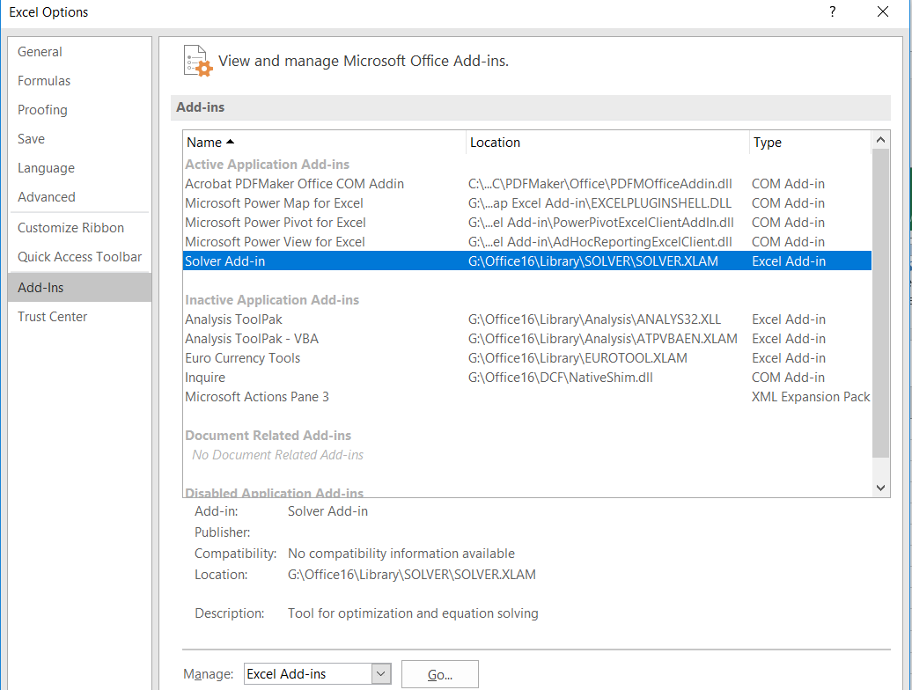

- Check Solver Add-In and click Ok.
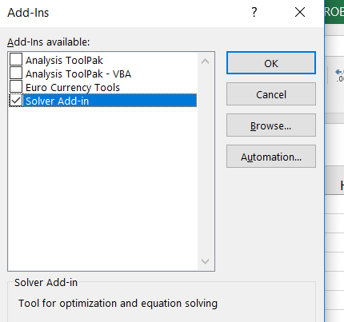

- You can find the solver on the Data tab, in the Analyse group.

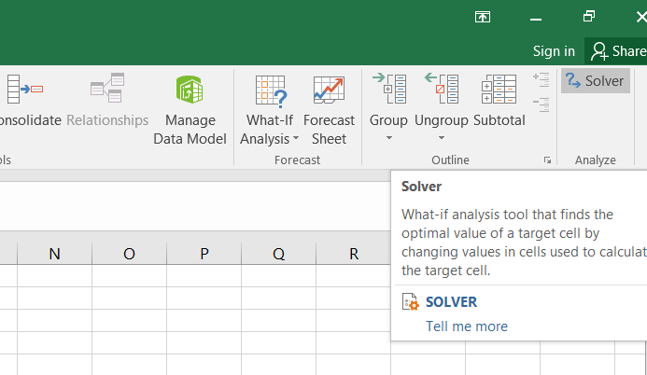

- Formulate the model as above and enter parameters in the dialog.

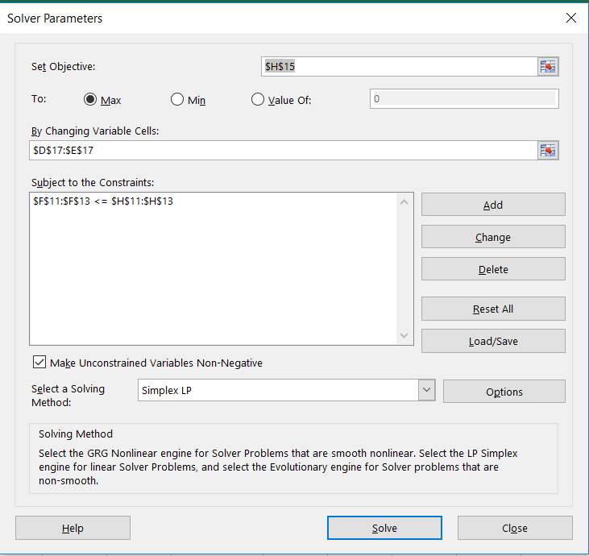

- Click Solve and you should see this message:
Solver found a solution. All constraints and optimality conditions are satisfied.
Generate Reports.

