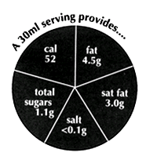
From label for `Crème fraîche' (Sainsbury's) 2006

