+c-'

::::l

0

u

100

80

60

40

20

Distribution of LIFE

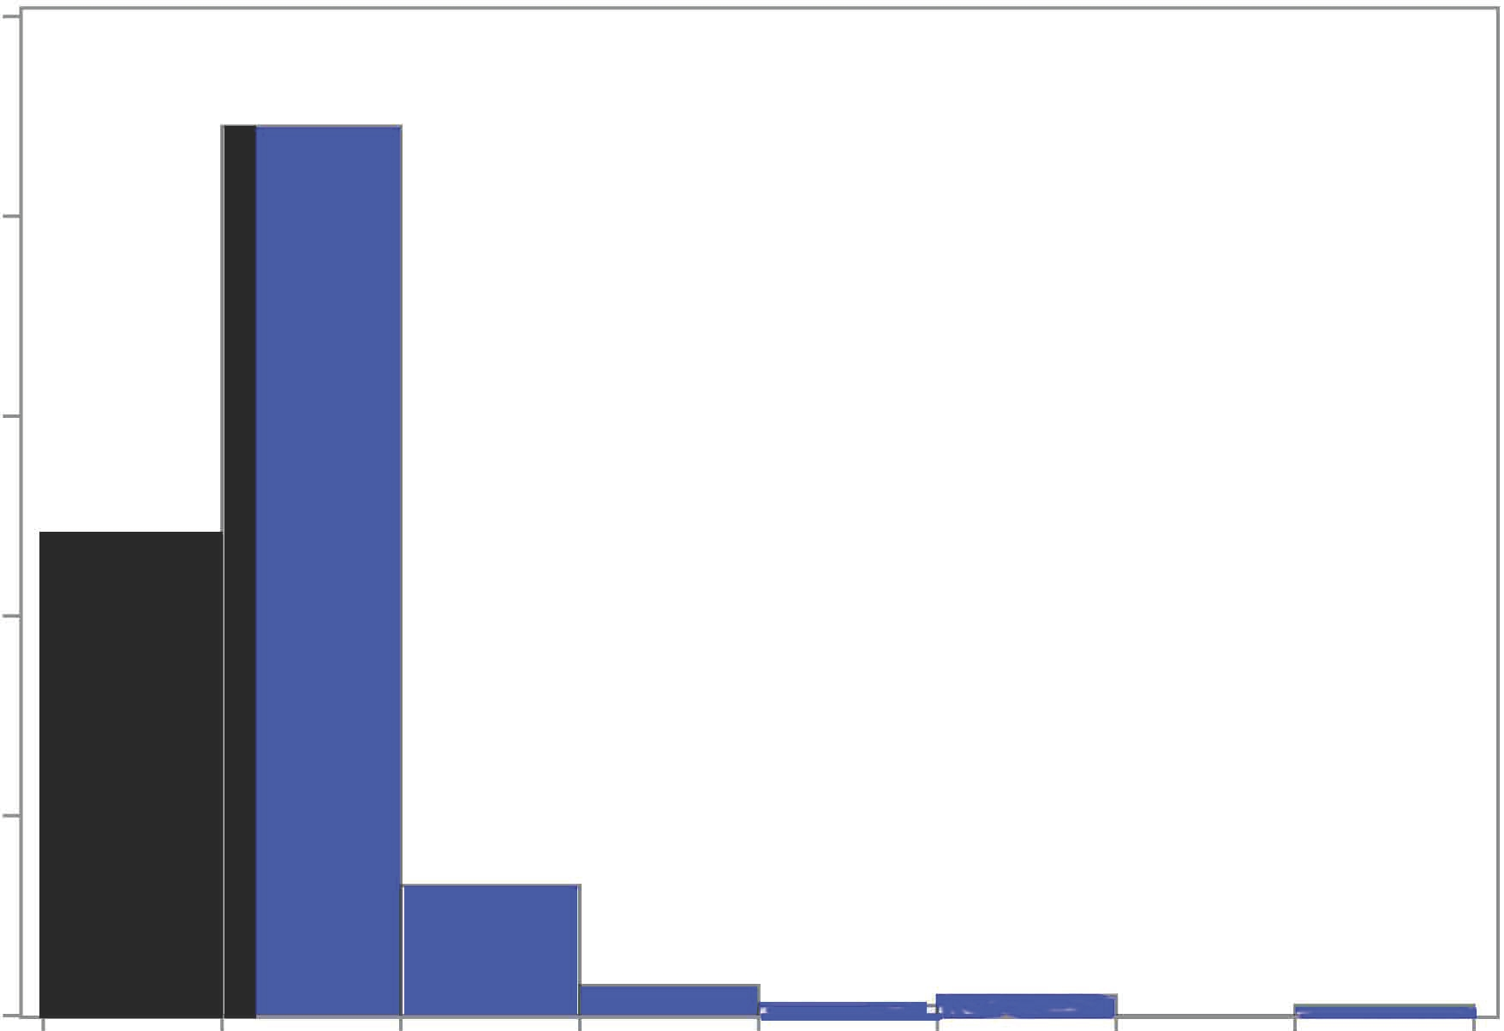0

0 15 30 45 60

LIFE

75 90 105 120