MME 523
Class #2 with notes added on Improper Integrals
Part One Lab activity
Here we are interesting in studying, with the help of software, the convergence of sequences generated recursively. This means they are of the form

x_{n+1} = f(x_{n}) x₀ given
Now f(x) could be almost anything so we need a place to start. The simplest functions are linear so we will assume f(x) = ax + b and proceed to investigate

the role of a, b and x₀ in the convergence of the subsequent sequence

You will generate a conjecture about this and then attempt to prove it for homework. But first you need to generate data, analyze it and gain experience with these sequences. The proving part will involve old fashioned paper and pencil.
Organization is important. Computers are good at generating lots of numbers fast; it is our job to then take notes and to proceed methodically so we are not merely groping around in the dark hoping to get lucky.
Your conjecture and proof are due next week.
Part Two Maple

Part Three Improper Integrals
Definition, review, discussion of improper integrals and their convergence/divergence
See notes from class below:

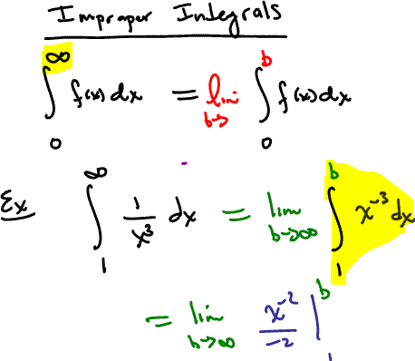

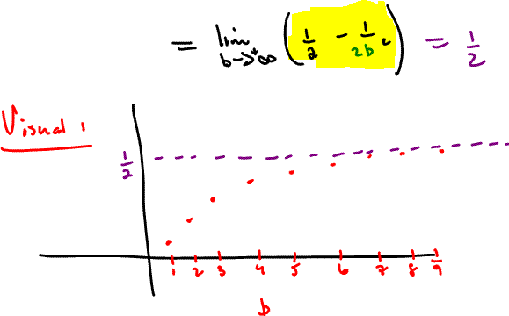
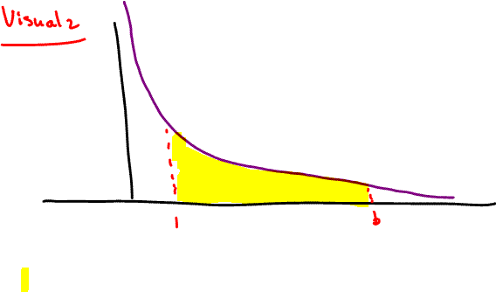

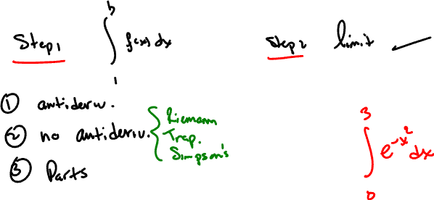

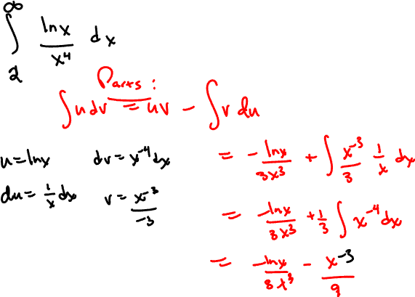
Graph of ln(x)/x⁴ is below, using Maple plot:
